**Assignment-1**

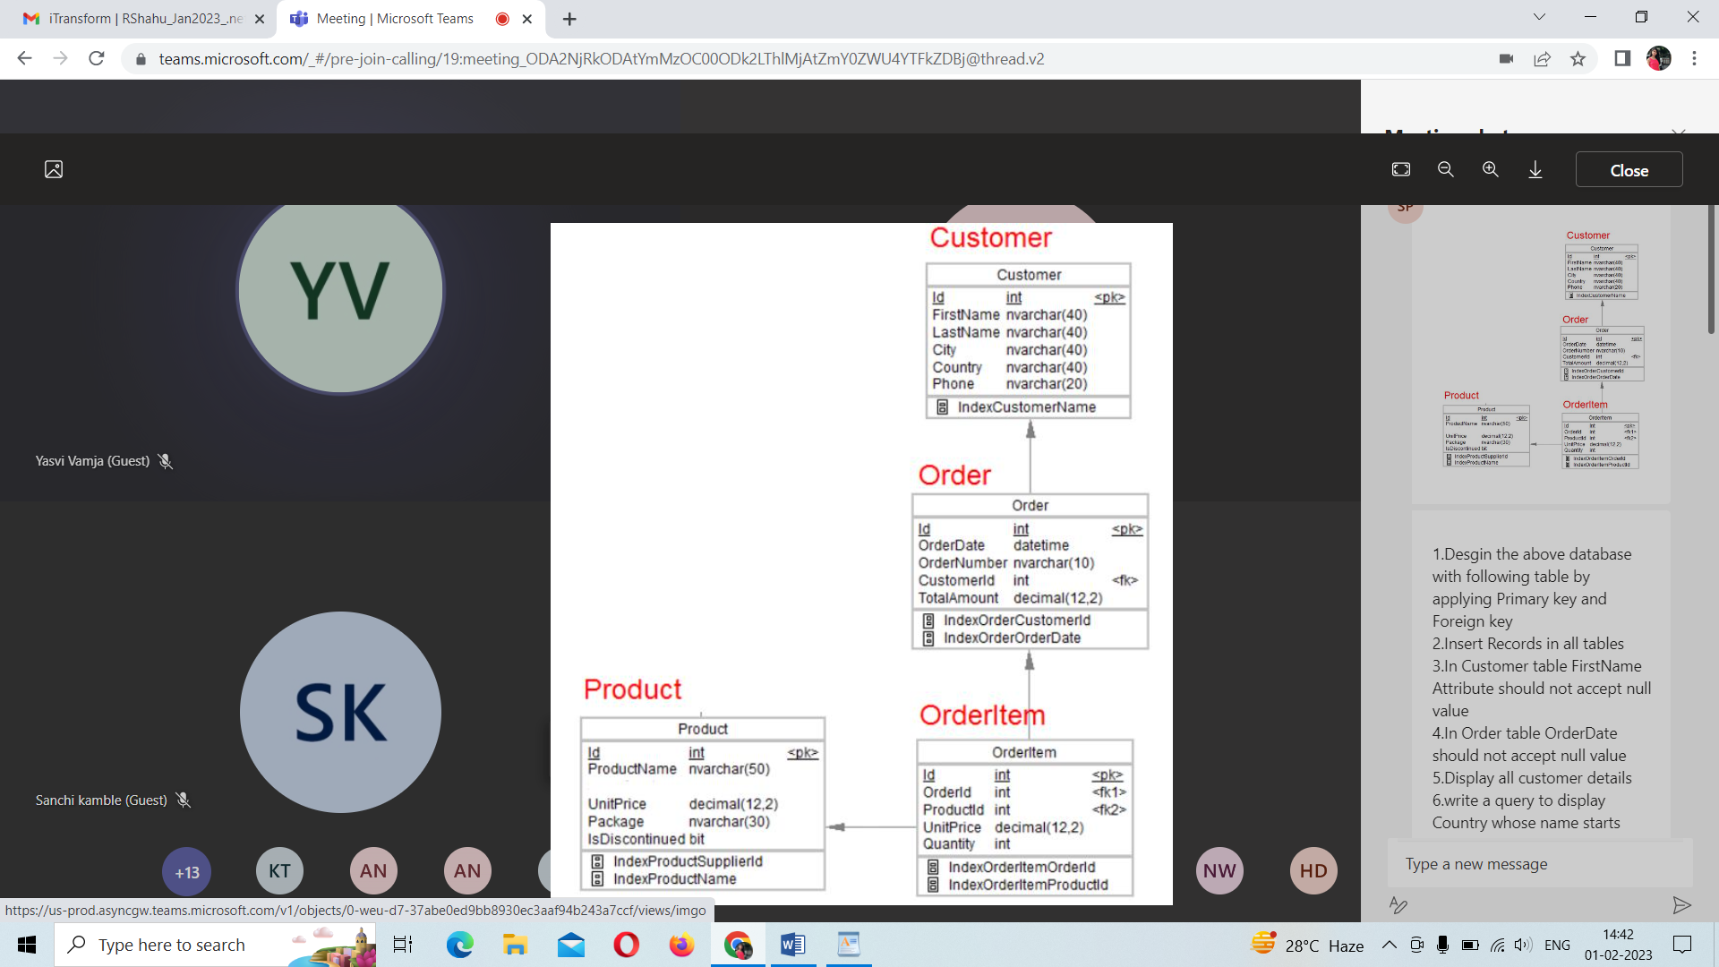

**Desgin the above database with following table by applying Primary key and Foreign key**

create table Customer

(

CustomerId int NOT NULL PRIMARY KEY,

FirstName varchar(40) NOT NULL,

LastName varchar(40),

City varchar(40),

Country varchar(40),

Phone varchar(20)

);

create table orders

(

orderId int NOT NULL PRIMARY KEY,

orderDate datetime NOT NULL,

orderNumber varchar(10),

customerId int FOREIGN KEY REFERENCES customer(customerId)

);

CREATE TABLE OrderItem

(

OrderItemId int NOT NULL PRIMARY KEY,

OrderId int FOREIGN KEY REFERENCES orders(orderId),

ProductId int FOREIGN KEY REFERENCES product(productId),

UnitPrice decimal(12,2),

Quantity int

);

create table Product

(

ProductId int primary key,

ProductName varchar(50),

UnitPrice decimal(12,2),

Package varchar(30),

IsDiscontinued bit

);

**Insert Records in all tables**

insert into Customer( id,FirstName,LastName,City,Country,Phone )

values (1,'Rama','Pandit','Pune','India','9850735612'),

(2,'Priya','Patel','Mumbai','India','9850735612'),

(3,'Alia','Sharma','Rome','Italy','9850735612'),

(4,'Anushri','Patel','Banglore','India','9585965656'),

(5,'Alis','Neo','London','England','7744858596'),

);

insert into orders values(1,'2000-12-12','101',1,123.23),

(2,'2001-12-1','101',2,123.23),

(3,'2002-1-1','101',3,123.23),

(4,'2003-9-12','101',4,123.23)

,(5,'2004-12-12','101',5,123.23),

(6,'2005-12-12','101',6,123.23);

insert into Product values(1,'Pen',10.0,'pack of 10',1), (2,'Sketchpen',30,'pack of 20',1);

insert into OrderItem values(1,1,2,20.203,10),

(2,2,2, 20.203,10),

(3,3,2, 20.203,10),

(4,4,2, 20.203,10),

(5,5,2,12.323,10),

(6,6,2, 20.203,10);

**In Customer table FirstName Attribute should not accept null value**

alter table Customer alter column Firstname nvarchar(40) not null;

**In Order table OrderDate should not accept null value**

alter table Orders alter column OrderDate datetime not null;

**Display all customer details**

select * from Customer;

**write a query to display Country whose name starts with A or I**

select Country from Customer where Country like 'A%' or Country like 'I%';

**write a query to display whose name of customer whose third character is i**

select * from Customer where FirstName like '__I%';

**Assignment-2**

**Display the details from Customer table who is from country Germany**

select * from Customer where Country='Germany';

**Display the full name of the employee**

select FirstName+‘ ’+LastName from Customer;

**Display the customer details who has Fax number add column**

ALTER TABLE Customer ADD FaxNumber nvarchar(20);

Select * from Customer Where FaxNumber is not Null;

**display the customer details whose name holds second letter as U**

Select * from Customer where FirstName like '_u%';

**select order Details where unit price is greater than 10 and less than 20**

select * from OrderItem where UnitPrice between 10 and 20;

**Display order details which contains shipping date and arrange the order by date**

select * from Orders order by OrderDate DESC;

**Print the orders shipped by ship name 'La corned'abondance' between 2 dates(Choose dates of your choice)**

create table ShippingDetails(

ship_id int primary key,

reference_number varchar(30) NOT NULL,

shipping_date datetime NOT NULL,

ship_name varchar(20),

is_operating binary,

Shipping_Comapany varchar(20),

order_id int FOREIGN KEY REFERENCES Orders(id)

);

Select * from orders where id in (select order_id from ShippingDetails where (ship_name=concat('La corned',char(39),'abondance'))

and Shipping_date between '2020-12-12' and '2022-12-12');

**Print the products supplied by 'Exotic Liquids'**

select * from Product where supplier='exotic liquids'

**print the average quantity ordered for every product**

select avg(Quantity) from OrderItem;

**Print all the Shipping company name and the ship names if they are operational**

Select Shipping_Comapany ,ship_name from ShippingDetails where is_operating=1;

**Print all Employees with Manager Name**

Created employee table

select e1.Firstname,e2.Firstname as 'manager' from employee as e1 join employee as e2 on e1.managerID=e2.EmpID;

**Print the bill for a given order id .bill should contain Productname, Categoryname,price after discount**

select prod_name, categoryname, (price-discount ) as bill_amount from product_supply where order_id='101';

**Print the Total price of orders which have the products supplied by 'Exotic Liquids' if the price is > 50 and also print it by Shipping company's Name**

alter table product_supply add shipping_company varchar(40);

update product_supply set shipping_company='xyz' where supplier_name='exotic liquids';

select sum(price) as 'Total_price' from product_supply where supplier_name='exotic liquids'

**Assignment-3**

**write a query to display the orders placed by customer with phone number 030-0074321**

SELECT o.OrderNUmber, c.id, c.FirstName, c.Phone FROM Orders as o, Customer as c

WHERE o.CustomerId = c.id AND c.Phone='030-0074321';

**Display the orders placed by customers not in London**

select * From Orders as o INNER Join Customer as c ON o.Customerid = c.id

and c.Country != 'London';

**fetching all the products which are available under Category ‘Seafood’.**

SELECT * FROM Product WHERE category ='SeaFood';

**selects all the order which are placed for the product Chai.**

select * From Orders where id in

(Select OrderId from OrderItem as o Inner Join Product as p ON o.Productid = p.id and ProductName= 'Chai')

**Write a query to display the name , department name and rating of any given employee**

SELECT e.Fname AS emp_name, d.Dname AS dept_name, e.rating FROM employee as e INNER JOIN department as d

ON e.depid=d.id;

**Print the Total price of orders which have the products supplied by 'Exotic Liquids' if the price is > 50 and also print it by Shipping company's Name**

SELECT SUM(price) As Total,CompanyName

FROM product_supply

where price >50

GROUP BY supplier_name,CompanyName having supplier_name ='exotic liquids';

**Display the employee details whose joined at first**

alter table employee add doj datetime;

select top(1) * from employee order by doj;

**Display the employee details whose joined at recently**

select top(1) * from employee order by doj desc

**Write a query to get most expense and least expensive Product list (name and unit price).**

select ProductName ,UnitPrice from Product where UnitPrice in((

select top(1) UnitPrice from Product order by UnitPrice desc),(

select top(1) UnitPrice from Product order by UnitPrice));

**Assignment-4**

**Display the list of products that are out of stock**

select *from Product where Available='Out of Stock';

**Display the list of products whose unitinstock is less than unitonorder**

select * from Product where unitinstock<unitonorder;

**Display list of categories and suppliers who supply products within those categories**

select category ,suppiler from Product order by category;

**Display complete list of customers, the OrderID and date of any orders they have made**

select c.id,c.FirstName,c.LastName,o.id as 'Order_id',o.OrderDate from Custermer as c left join Orders as o on c.id=o.Customerid;

**Write query that determines the customer who has placed the maximum number of orders**

SELECT TOP 1 CustomerId, COUNT(Id) AS order_count FROM Orders GROUP BY CustomerId ORDER BY order_count DESC;

**Display the customerid whose name has substring ‘RA’**

select CustomerId from customer where FirstName like '%ra%'

**Display the first word of all the company name**

select substring(Shipping_Comapany,1,charindex(' ',Shipping_Comapany)) as 'NAME' from ShippingDetails;